HACKATHON 2.0
Software Product Requirements Document (PRD)

TalentriX
Credibility-First Talent & Employment Platform

September 2026

1. Document Information & Product Summary
Product Name | TalentriX
Solution Type | Software - Responsive Web Application
Prepared By | Quantum Minds
Document Version | 1.0
Date | September 2026

Product Summary
TalentriX is talent agency that connects talents with employers for remote, onsite, full-time, and contract opportunities, while discovering and matching talents with relevant jobs, hubs with relevant grants, and other opportunities.

Why This PRD Exists
This PRD converts the TalentriX concept into a clear, testable plan for the hackathon. Version 1.0 narrows the Week 1-3 build to the specific roles, features, and monetization mechanics the team has confirmed it can realistically deliver, and removes anything that is not part of that confirmed scope.

2. Problem Statement

Talented people struggle to find credible employment and funding opportunities, while companies struggle to find verified skilled talent. TalentriX bridges both sides through verified talent, smart matching, and automated opportunity discovery.

Problem Evidence / Assumptions to Validate
- Skilled individuals, including graduates of hubs, bootcamps, and training programs, often lack a credible, verifiable way to prove their skills to employers who do not recognize the issuing hub.
- Employers spend significant time and money vetting candidates because credentials and skill claims on generic job boards and CVs are hard to verify at a glance.
- Talent that is not affiliated with any hub still needs a credible way to present itself; a self-service profile and shareable portfolio link addresses this without requiring third-party accreditation.
- Hubs currently have limited direct incentive or channel to get their graduates placed with paying employers; a reputation and commission mechanism gives them a reason to actively route talent through the platform.

3. Product Goal & Objectives

Product Goal
Build a platform where hubs list accredited talents, independent jobseekers present themselves via profile + auto-generated portfolio link, and employers pay a fixed access fee to unlock contact with a specific talent - with hubs earning commission and reputation points from that activity.

Project Objectives
ID | Objective | How Completion Will Be Gauged
01 | Talent/Job-Seekers creates profile + receives auto-generated portfolio link | Link generated and accessible on completion
02 | Talent/Job-Seekers get a browsable job catalogue | Catalogue lists all open opportunities
03 | Hubs get a dashboard to manage their talent roster | Added talent reflects in roster instantly
04 | Employers search for talents and pay ₦5,000 to unlock a specific talents | Payment confirms and unlocks contact
05 | Hub commission & reputation points are tracked and displayed | Ledger entries update after payment/hire
The objectives are intentionally specific enough to be checked against the completed MVP. Extra objectives should only be added where they represent meaningful, achievable project outcomes.

4. Target Users & Personas
The platform has exactly three user categories. There is no separate general ‘admin’ role in the Week 1-3 scope.
User | Need | Typical Action | Success Condition
Hub (has talents under it) | A channel to place its accredited talents with paying employers and be rewarded for doing so | Register as a hub, add talents to its roster, monitor reputation points and commission | Its talents get hired through the platform and the hub earns commission and reputation points
Employer (already skilled person/company seeking talent) | Fast access to talent it can trust is credible, without lengthy independent vetting | Browse the talent list, pay ₦5,000 to unlock a specific talent, message and decide | Reaches a hire/no-hire decision on a credible candidate without wasted vetting time
Jobseeker not under any hub | A credible way to present itself and be discovered even without hub accreditation | Create a profile, receive an auto-generated portfolio link, appear in the job catalogue | Gets discovered by employers using the portfolio link and catalogue listing

Primary Persona (FOLLOWING THE GIVEN SAMPLE)
Peter was given a grant by federal government and one of the requirements was to employ a backend developer; he’s currently stuck on getting a credible backend developer; so he opened TalentriX for a credible backend developer from Verified Tech-Hubs.

5. Value Proposition & Significance
TalentriX’s core value is intended credibility, not simply job listings. Each user group is offered a specific, concrete reason to use the platform:
- For hubs: a direct, trackable incentive to place their graduates - reputation points when a talent is hired through the platform, and a commission from every ₦5,000 access fee an employer pays to reach one of their talents.
- For employers: they pay only when they want to contact a specific talent, and that fee buys access to talent who has been verified, reducing blind vetting.
- For independent jobseekers: a professional, auto-generated portfolio link and catalogue visibility without needing prior hub accreditation.

6. Proposed Solution & User Experience
The MVP is a responsive web application built around three interfaces: a Hub Dashboard, an Employer Dashboard, and a Jobseeker profile/catalogue experience. Every talent, whether hub-affiliated or independent, completes a profile and receives an auto-generated portfolio link. Employers reach a specific talent by paying a fixed ₦5,000 fee that unlocks direct contact until a hire decision is recorded.
Primary Users Reporting Flow
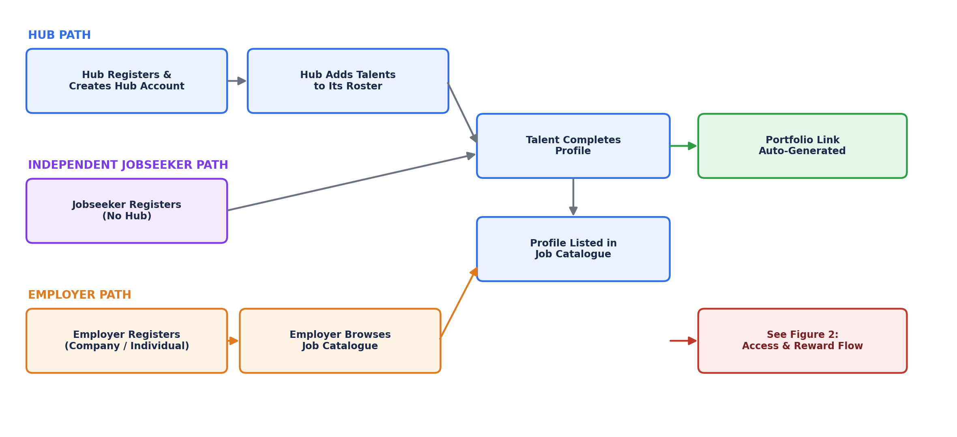
Figure 1. Onboarding paths for hubs, independent jobseekers, and employers into the shared profile/catalogue pool.
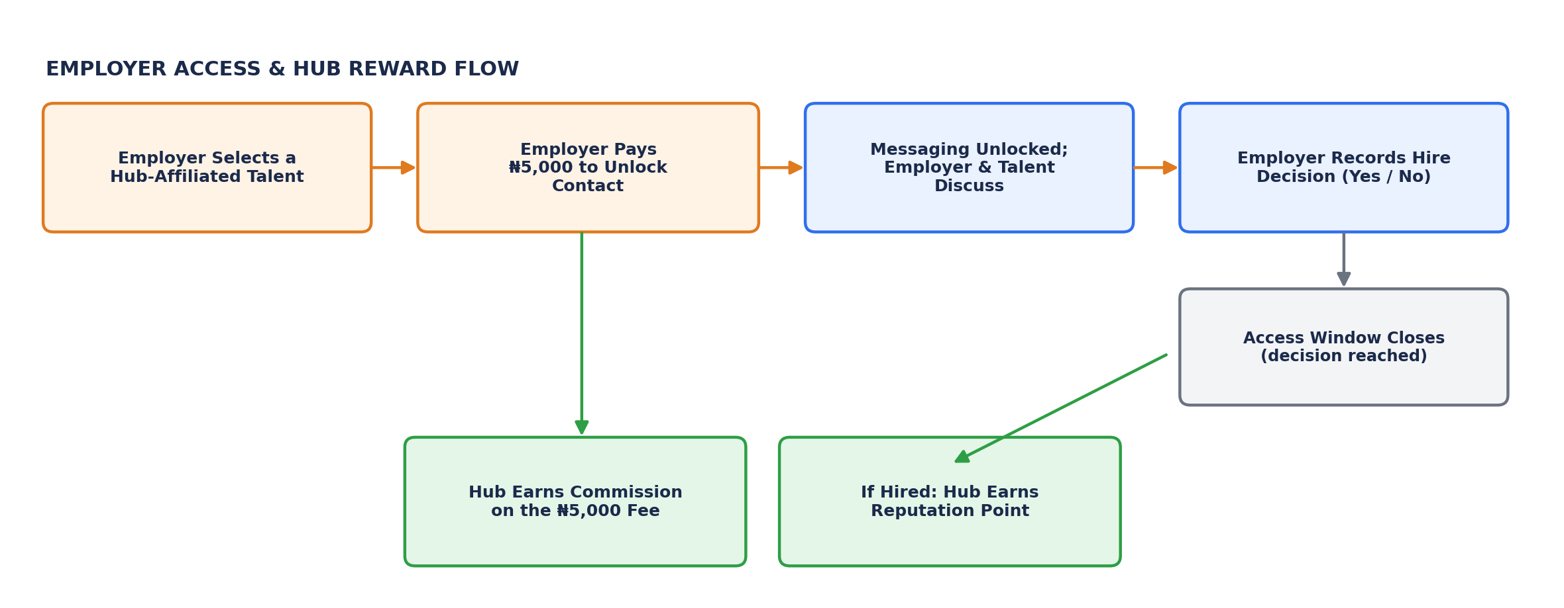
Figure 2. Employer access-gating flow and the resulting hub commission and reputation reward.
Figures 1 & 2. Illustrative primary users flow.

NOTE: Week 1 wireframes for the Hub Dashboard, Employer Dashboard, and profile/portfolio screens should be produced separately to demonstrate layout and interaction; the diagrams above illustrate flow and logic rather than final screen design.

WIRE FRAME(S) HERE/BELOW:

Figure 3. Low-fidelity wireframe for the Hub Dashboard, Employer Dashboard, and profile/portfolio screens
NOTE: A Week 1 wireframe does not need to be visually polished; it should demonstrate layout, hierarchy, and intended interaction

7. Functional Requirements
ID | Requirement | Priority | Primary User | Acceptance Summary
FR-01 | Create and edit a talent profile (hub-affiliated or independent) | Must | Talent | Profile is saved with the fields required to publish it
FR-02 | Auto-generate a shareable portfolio link once a profile is completed | Must | Talent | A working, unique link is created and accessible without login
FR-03 | Display a job catalogue of posted opportunities | Must | Jobseeker | Catalogue lists all currently open opportunities
FR-04
FR-04 | Hub dashboard: manage talents on the hub's roster | Must | Hub | Added talent appears in the hub's roster and is marked hub-affiliated
FR-05 | Employer dashboard: browse talents and select a specific talent | Must | Employer | Employer can view limited (locked) talent details before payment
FR-06 | Employer pays ₦5,000 to unlock contact/messaging with a selected talent. | Must | Employer | Payment is confirmed and contact access is unlocked for that talent
FR-07 | Unlocked access remains active until the employer records a hire decision (Yes/No) for that talent | Must | Employer | Access state changes to closed once a decision is recorded
FR-08 | In-platform messaging between an employer and an unlocked talent | Should | Employer, Talent | Messages are exchanged and stored within the platform
FR-09 | Authenticate users with role-based access (Hub, Employer, Jobseeker) | Must | All | Each dashboard/profile view is inaccessible without valid login for that role

8. Non-Functional Requirements
Area | Requirement | Target / Constraint | Verification
Usability | Profile creation and portfolio link generation should be simple on mobile and desktop | Profile completion in a small, clear number of steps | Task walkthrough/user test
Performance | Catalogue and dashboard pages should respond promptly under demo load | Most requests in few minutes in test environment | Basic timing tests
Security | Payment, contact-unlock, and dashboard actions require authentication and authorization | No hub/employer dashboard endpoint accessible anonymously; payment confirmed server-side before unlocking access | Access-control and payment-verification tests
Data validation | Required profile fields and payment inputs are validated | Reject incomplete profiles and unconfirmed/failed payments | Negative tests
Privacy | Collect only information needed for profile, catalogue, payment, and access-gating functions | Restrict payment and contact-unlock records to the employer, the relevant hub, and the platform | PRD/data review

9. MVP Scope & Prioritization
The MVP is the smallest version that demonstrates the full credibility-and-access loop: a hub or independent jobseeker builds a credible profile, an employer finds that talent through the catalogue, pays to unlock contact, and a hire decision generates a reward for the hub. Everything below reflects only what the team has confirmed for this hackathon.
Priority | Included | Reason | Hackathon Decision
Must | Talent profile + auto-generated portfolio link, job catalogue, hub dashboard, employer dashboard, in-platform messaging between employer and unlocked talent. | These are the exact features and mechanics the team has committed to delivering | Build and test first
Should | In-chat Call | For Second Interview verification by the employer. | Build after Must features are stable
Could | Basic notifications (e.g. payment confirmation, hire decision recorded) and AI integration | Improves experience but is not required to prove the core loop | Only if time remains
Out of Scope | AI-based opportunity matching, native mobile apps, automated verification | Not part of the confirmed feature list for this hackathon; removed to keep scope realistic and achievable | Document as future work

10. System Architecture & Technical Design

Illustrative MVP System Architecture
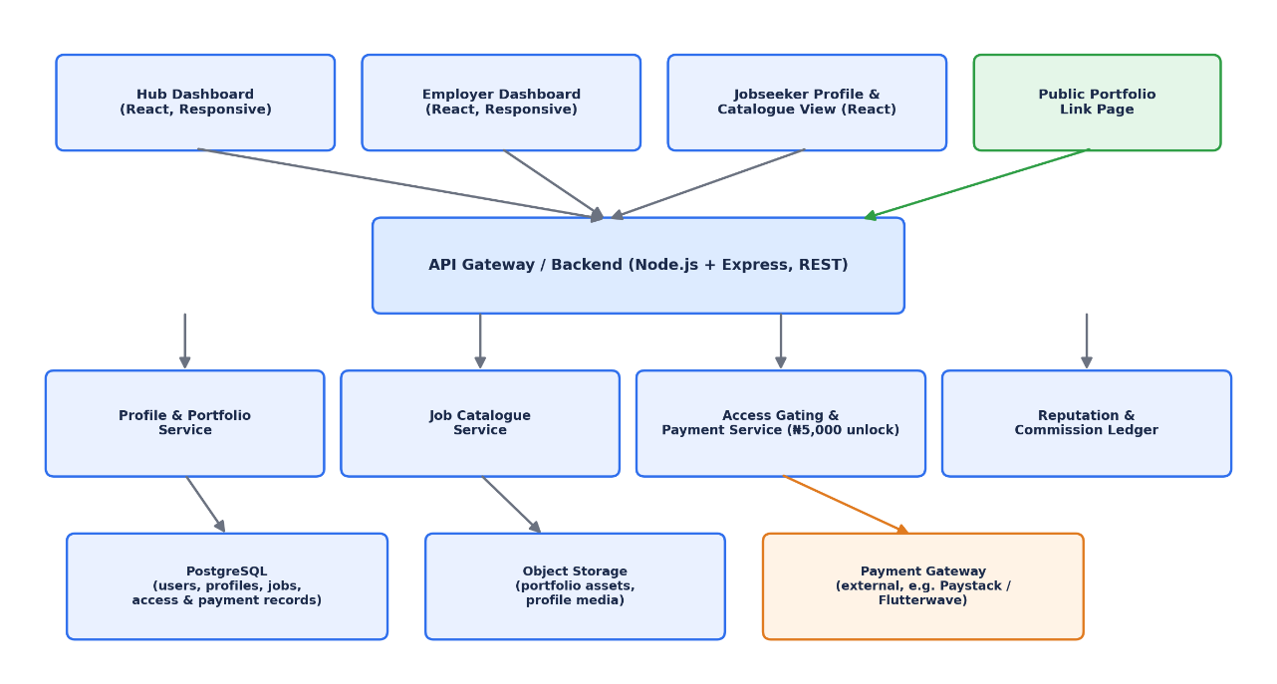
Figure 3. Illustrative MVP architecture.

Proposed Technology Stack
Layer | Illustrative Choice | Rationale
Frontend | React / responsive web UI | One codebase serving the Hub Dashboard, Employer Dashboard, and jobseeker/catalogue views across devices
Backend | Node.js + Express (REST API) | Simple, well-understood API layer suitable for a three-week build
Database | MongoDB | Structured relational data for users, profiles, jobs, access-unlock records, payments, commission, and reputation points
Payments | Third-party payment gateway (e.g. Monnify) for the ₦5,000 access fee | Avoids building custom payment/card handling within the hackathon window
Portfolio hosting | Server-generated public page per talent, served at a unique URL | Delivers the auto-generated, shareable portfolio link
Deployment | Cloud-hosted web service | Allows judges and test users to access the live MVP

Core Data Entities
- User: hub, employer, or jobseeker identity, role, authentication information.
- Talent Profile: skills, experience, hub affiliation (nullable for independent jobseekers), portfolio link.
- Hub: name, verification status, list of affiliated talents.
- Opportunity: title, description, requirements, posted by which employer.
- Access Unlock: employer, talent, payment reference, unlock timestamp, hire-decision status (open/closed).
- Payment: amount (₦5,000 per unlock), payer, status, timestamp.

Key Technical Decisions
- Use a third-party payment gateway rather than a custom payment system to keep the hackathon build realistic.
- Defer AI-based matching and grant/scholarship/fellowship discovery beyond this hackathon MVP. The confirmed Week 1-3 build prioritizes the credibility and access-gating loop, since that is what the team can realistically deliver and what differentiates and monetizes the product first; AI-assisted matching remains a documented Phase 2 roadmap item consistent with the product's longer-term description.
- Treat the ₦5,000 access fee as scoped to talent only, per the confirmed business model.

11. Acceptance Criteria & Success Metrics
Objective / Area | MVP Acceptance Criterion | Evidence | Pass Condition
01 - Profile & portfolio link | Talent can complete a profile and receive a working portfolio link | Live demo + test record | Link is generated and loads the talent's profile
02 - Job catalogue | Jobseeker can view posted opportunities in the catalogue | Live demo | Catalogue reflects opportunities posted
03 - Hub roster | Hub see talents reflected on its dashboard | Live demo | Talent appears in the hub's roster immediately after being registered
04 - Access gating | Employer can pay ₦5,000 (test transaction) and gain contact access to a specific talent | Live demo + payment gateway test/sandbox record | Access unlock record is created and contact becomes available
Reliability | Defined core test cases complete without blocking failure | Test checklist | At least 90% of core test cases pass before final demo

12. Risks, Constraints & Assumptions
Risk / Constraint | Impact | Likelihood | Mitigation
Limited hackathon time to build profile, catalogue, two dashboards, and payment logic | High | High | Freeze the Must-have list; build payment/access-gating logic before optional messaging
Payment gateway integration issues (sandbox limits, verification delays) | Medium | Medium | Integrate the payment gateway early in Week 2 and use its test/sandbox mode for the demo
No real hub partners onboarded before the demo | Medium | High | Use one or two seeded demo hub accounts with realistic sample talents for the presentation
Reputation points could be gamed (e.g. fake hire decisions with no real employment) | Medium | Medium | Document this as a known MVP limitation; note that production would need hire verification
Unauthorized access to hub commission data or employer payment records | High | Low-Medium | Restrict dashboard and ledger endpoints by authenticated role; test access control before demo

Assumptions
- The MVP is a proof of concept for the hackathon and not a fully compliant, production-ready payments platform.
- Test users have internet access, a modern browser, and access to a test payment method for the sandboxed gateway.
- A small number of demo hub accounts will represent the hub role for the MVP.
- The ₦5,000 figure and the commission percentage are the team's confirmed intended pricing for the MVP; the exact commission percentage should be finalized and documented before Week 2.

13. Development Plan & Milestones
Period | Primary Outcome | Planned Evidence | Exit Check
Week 1 - Planning & Design | Validated scope (this PRD), wireframes for the three dashboards/views, architecture diagram, backlog | PRD, flow diagrams, wireframes, architecture diagram, repository/setup evidence | Scope matches Section 9 exactly; architecture is agreed
Week 2 - MVP Foundation | Profile creation, portfolio link generation, job catalogue, and hub/employer dashboards working end-to-end | Working profile + portfolio link, catalogue, dashboard UI, initial payment gateway integration, commits/technical notes | Core foundation works and payment/access-gating integration has started
Week 3 - MVP Completion & Testing | Complete access-gating, commission, and reputation-point logic; validate reliability | Integrated MVP, test results, bug fixes, updated documentation | Essential functions work and core tests are documented
Final Preparation | Stabilize and prepare demonstration | Bug fixes, demo dataset (seeded hubs/talents/employers), pitch/demo rehearsal | Reliable demo and clear explanation of the credibility and access-gating loop

14. Open Questions / Decisions Pending
Question | Current Decision / Direction
Does the ₦5,000 access fee also apply to independent jobseekers not under a hub, or are they contacted directly at no fee? | Yes
What defines a ‘reputable organization’ for reputation-point purposes, if only some hires should count? | For MVP, treat every employer on the platform as qualifying; refine eligibility criteria post-MVP if needed.
What is the exact commission percentage or amount the hub receives per ₦5,000 payment? | To be finalized by the team before Week 2 build; not yet fixed in this document.
What happens if an employer never records a hire decision (Yes/No)? | Proposed: access auto-closes after a defined inactivity period; exact duration to be decided in Week 2.
Which payment gateway will be integrated (Paystack, Flutterwave, or another)? | Monnify
Do we carry out interviews before accepting applicants (talents and co.) to our platform, to ensure and implement accurate verification/credibility …? | Yes

